Long Term Size Issue

We need the layout like “Products Tab” in the admin section

So when you click the Size Tab it will goes Brands > Categories (With a column for Gender)

1. 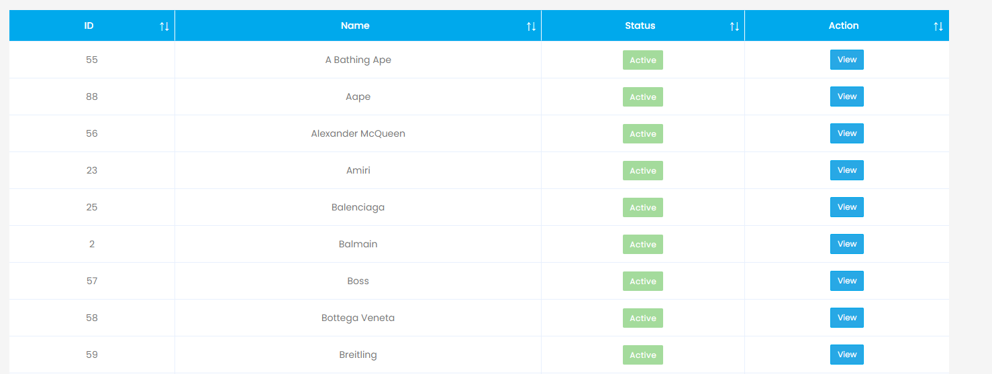
2. 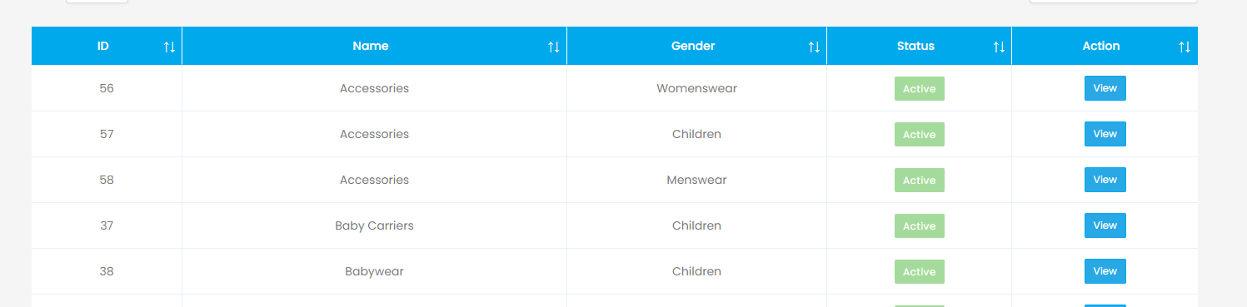

Then within in Category / Gender it allows me to add specific Sizes relating to that

Then when we manually upload a product in the Admin Section, it will shoe all sizes listed to that Brand > Category / Gender

But we will have 2 tick a boxes

1. To show the product is instock (We enter quantity amount like normal)

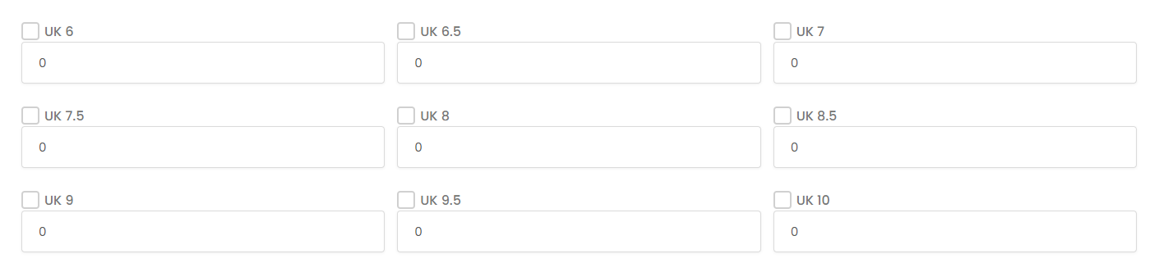

1. so that only a select few of the sizes are shown on the product page (Client side)

As there will be different sizes per category, not all of them will be shown on the product page that the client sees. So we need another tick box to so that I can tick it to show those products are related to that product

